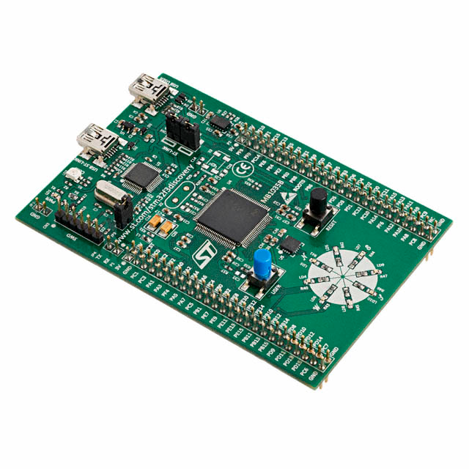 | COMPUTER SCIENCE DEPARTMENT  TE2004B – ADVANCED EMBEDDED SYSTEMS DESIGN  LAB #1 – Discrete convolution
 | Name: _________________________  ID: _________________________ | Name: _________________________  ID: _________________________
 | Name: _________________________  ID: _________________________ | Name: _________________________  ID: _________________________

Instructions:

- Configure a voltage source with the following parameters:

  - Amplitude: +3 V
  - Offset: 0 V

Connect the voltage source (via channel 1) in order to verify the correctness of the required signal. Skipping this step can result in damaging the STM32F3DISCOVERY board.

- Connect the output of the function generator to both the oscilloscope (via channel 1) and to the board’s PB15 pin. Then connect another channel of the oscilloscope to the board’s PA4 pin.

- Generate a new project with a 48 MHz clock signal (Figure 1.2).and replace the main function with the program in Listing 1.1.

Figure 1.2. Setting the 48 MHz clock frequency

- Replace the main function and add the functions into the project from the program in Listing 1.

Listing 1. Convolution program with SYSCLK = 48 MHz, ADC34.5 = PB15 and DAC1 = PA4
uint16_t ADCRead( void );

/* USER CODE BEGIN PFP */

/* USER CODE END PFP */

/* Private user code ---------------------------------------------------------*/
/* USER CODE BEGIN 0 */

/* USER CODE END 0 */

/**
* @brief The application entry point.
* @retval int
*/
int main(void)
{
HAL_Init();
SystemClock_Config();

// Setting PE8 (LD8-BLUE) as digital output
RCC->AHBENR |= RCC_AHBENR_GPIODEN;
GPIOD->MODER |= GPIO_MODER_MODER8_0;

// [18]: IOPBEN: I/O port B clock enable = 1 -> I/O port B clock enabled
RCC->AHBENR |= RCC_AHBENR_GPIOBEN;
// [31:30]: MODER15[1:0]: Pin B.15 mode = 11 -> Analog function mode
GPIOB->MODER |= GPIO_MODER_MODER15;
// [13:9]: ADC34PRES[4:0]: ADC34 prescaler = 10000 -> PLL clock divided by 1
RCC->CFGR2 |= RCC_CFGR2_ADCPRE34_DIV1;
// [29]: ADC34EN: ADC3 and ADC4 enable = 1 -> ADC3 and ADC4 clock enabled
RCC->AHBENR |= RCC_AHBENR_ADC34EN;
// [29:28]: ADVREGEN[1:0]: ADC voltage regulator enable = 00 -> Intermediate state
// [29:28]:ADVREGEN[1:0]: ADC voltage regulator enable = 01 -> Enabled state
// [31]: ADCAL: ADC calibration = 1 -> Start ADC calibration
ADC4->CR &= ~ADC_CR_ADVREGEN; // In order to enable the regulator, first it must be switched
ADC4->CR |= ADC_CR_ADVREGEN_0; // into the intermediate state (OFF), then into the enabled one
HAL_Delay(1); // (ON) and finally must wait ~1ms in order to stabilize
ADC4->CR |= ADC_CR_ADCAL;
while( ADC4->CR & ADC_CR_ADCAL ); // Waiting for calibration to finish

// [4:3]: RES[1:0]: Data resolution = 00 -> 12-bit
// [5]: ALIGN: Data alignment = 0 -> Right alignment
// [13]: MODER9[1:0]: Single/continuous conversion mode = 0 -> Single conversion mode
// for regular conversions
ADC4->CFGR &= ~ADC_CFGR_RES;
ADC4->CFGR &= ~ADC_CFGR_ALIGN;
ADC4->CFGR &= ~ADC_CFGR_CONT;

// [3:0]: L[3:0]: Regular channel sequence length = 0000 -> 1 conversion
// [10:6]: SQ1[4:0]: 1st conversion in regular sequence = 00101 -> Channel 5 is mapped into 1st
// conversion placeholder
ADC4->SQR1 &= ~ADC_SQR1_L;
ADC4->SQR1 |= 5<<6;

// [19:18]: SMP5[2:0]: Channel 5 sampling time selection = 000 -> 1.5 ADC clock cycles
ADC4->SMPR1 &= ~ADC_SMPR1_SMP5;

// [0]: ADEN: ADC enable control = 0 -> ADC Enabled
ADC4->CR |= ADC_CR_ADEN;
while( !( ADC4->ISR & ADC_ISR_ADRD ) ); // Waiting for ADC to stabilize

// Setting PA4 as DAC
RCC->AHBENR |= RCC_AHBENR_GPIOAEN;
GPIOA->MODER |= GPIO_MODER_MODER4;
RCC->APB1ENR |= RCC_APB1ENR_DAC1EN;
DAC->CR |= DAC_CR_EN1;

/* Configuring TIM2 as Base Timer with T = 0.5s with interruption support */
RCC->APB1ENR |= RCC_APB1ENR_TIM2EN;
TIM2->PSC = 1 - 1;
TIM2->ARR = 72000 - 1;
TIM2->CNT = 0;
TIM2->DIER |= TIM_DIER_UIE;
NVIC_EnableIRQ(TIM2_IRQn);
__enable_irq();
TIM2->CR1 |= TIM_CR1_CEN;

while (1)
{

}
}

void TIM2_IRQHandler(void)
{
// Number of elements in input vector and filter
int32_t K = 3;

// Inputs vector
static float X[3] = {};

// Filter coefficients
static float B[3] = {1.0, 0.0, 0.0};

// Output per sample
float y = 0.0;

// Index of new input sample
static int32_t xZero = 0;

// Counter for the number of elements in the inputs vector
int32_t k = 0;

TIM2->SR &= ~TIM_SR_UIF;
GPIOD->ODR |= (1<<8);

X[xZero] = (float)ADCRead(); // Save the new sample into the zero of the inputs vector
y = 0.0;
for( k=0; k<K; k++ ) // Make convolution between the filter vector and inputs vector
{
y += X[xZero]*B[k];
if( --xZero < 0 ) // Traverse circularly the inputs vector.
// If going before the index zero, set index
// to the greatest one inside the vector
{
xZero = K - 1;
}
}
if( ++xZero > K - 1 ) // Set a new xZero value in order to save next sample
// If going after the greatest index in the array, set
// index to zero
{
xZero = 0;
}

if(y > 4095.0)
y = 4095.0;
else if(y < 0.0)
y = 0.0;

DAC->DHR12R1 = (uint16_t)y;
GPIOD->ODR &= ~(1<<8);
}

uint16_t ADCRead( void )
{
uint16_t adcInput;

// [2]: ADSTART: ADC start of regular conversion = 1 -> Regular Conversion Started
ADC4->CR |= ADC_CR_ADSTART;
while( !( ADC4->ISR & ADC_ISR_EOC ) ); // Waiting for end of conversion
adcInput = ADC4->DR & 0xFFF; // Reading and adjusting ADC 12-bit value

return adcInput; // Returning ADC data
}

- Modify the program in Listing 1 to the sampling frequency required to covolve a step function with a unit impulse and delay its output 5 seconds.

- Take a picture of the oscilloscope output.

Picture 1. Screenshot for the unit impulse response

- Explain how did you get reported result for this project (and also how it works):
Listing 2. Description for the convolution program

